sbt package

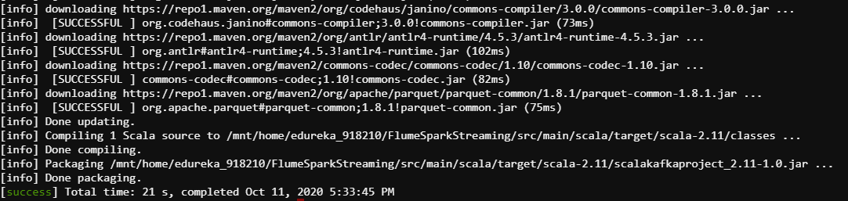

flume-ng agent -n stlog -f /mnt/home/edureka_918210/FlumeSparkStreaming/src/main/scala/stlog.conf -Dflume.root.logger=INFO,console

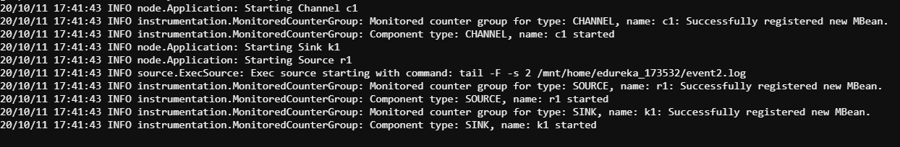



spark2-submit --class LogParser --deploy-mode client /mnt/home/edureka_918210/FlumeSparkStreaming/src/main/scala/target/scala-2.11/scalakafkaproject_2.11-1.0.jar

